Sana Khan

IST 659 Project

2/13/2022

Part One

Business Plan:

Why settle for boring coffee that doesn’t even taste good, when you can get a coffee of your choice delivered right to your door? With a membership to Coco’s Coffee Club you’ll have the opportunity to try unique coffees from all over the world. We partner with roasters who carefully curate their selection by working with independent farmers to bring a wide variety of options to choose from. You can then customize your subscription by letting us know your preferences so we can match you to what you like. Or you can be bold and let us send you something new to try! Either way, your days are going to start off a lot better than before.

Stakeholders:

* Roasters – those who are sourcing and roasting coffees to send to our customers
* Customers – those who have an active subscription

Business Rules:

* There are two tiers that a customer can select for as part of their membership, standard or deluxe. A standard subscription is $14.99 and a deluxe subscription is $19.99. A deluxe subscription unlocks access to more single origin and lighter roast coffees
* Customers can pick the frequency to be once a week, bi-weekly, or monthly
* Subscriptions will auto renew
* There is a flat rate $5 shipping. This is subject to change
* Customers must use a credit card for payment
* Customers can cancel or pause their membership

Data Questions:

* How many active subscriptions do we have at a point in time?
* Where are our roasters located?
* What are our most popular coffees?
* How many customers canceled their membership
* What cities do our customers live in?

Conceptual Model:

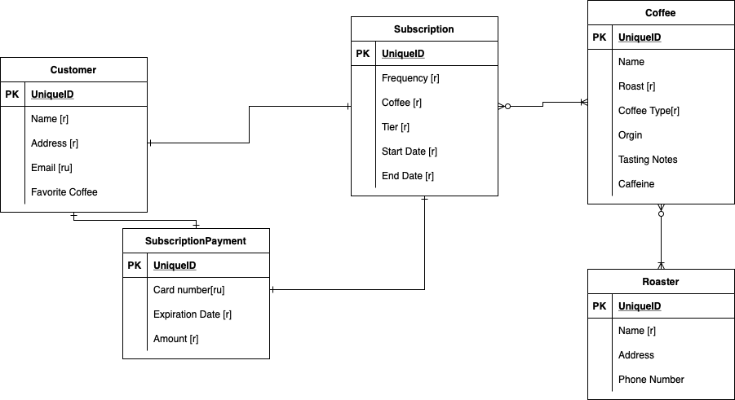

Logical Model:

